OCR GCE A

Computer Science Project

H446-03

--------------------------------------------------------------------------------------------------------------------------------------

Name: Omar Gaad

Candidate Number: 0096

School: Preston Manor High School

Title of Project:

Contents

Contents

Part A: Analysis 3

Problem Identification 3

Thinking Abstractly 3

Thinking Ahead 3

Thinking Procedurally 3

Thinking Logically 3

Thinking Concurrently 4

Heuristics 4

Visualisation 4

Software Methodologies 4

# Part A: Analysis

## Problem Identification

A social deduction game known as Mafia is a game that involves people in the group having to guess who the “mafia” is before they eliminate everyone at night. The main issue with this game is simply the fact that not everyone can play as one person must take on the role as the “host” and carry out game management tasks such as assigning roles, counting votes, making announcements and more. However, this issue can be solved through computational methods by programming a computer or device to act as the “host” of the game, letting it complete all the repetitive, technical and logical tasks a human host would have to do. There are non-computational solutions such as using cards to manage the game, however a host player is still required. What justifies the computational approach is that despite the main limitation of there being a large possibility of players being able to cheat - due to the lack of host supervision - there are many valuable benefits to having a computer host over a human host that outweigh this drawback, such as:

* Avoidance of bias: A human host may choose a particular player to be the mafia over others intentionally, while a computer can randomly generate roles to increase fairness.
* Reduced Error: The game can clearly define and remember the number of votes, the player chosen to be eliminated and the number of players on each team, while a human host may forget or make a mistake.
* Accessibility: Everyone can play; no one is left out to be the host, giving everyone a chance at experiencing the game.

The “host” problem was made clear to me last year when I was playing with my cousins, Ali and Bilal. When we would play together, there would not be enough players present as someone was confined to the host role. After explaining to them my solution, they gained an interest in the project as it can allow an improved user experience to the game, being easily accessible electronically (via their phones), showing how this can be an excellent solution, suitable for a younger teenage audience.

The main features of my program will include:

* Login System and Database: to store/access game history and gamemodes
* Timer: To allow discussion sessions before voting
* Voting System: Allows players to decide who to execute
* Flashcard System: To assign roles to individual players privately and randomly
* Audio System: Allows to host to communicate to the players while their eyes are closed at the night stage
* Custom Game Setup: Allows players to choose the number of mafia, roles etc. and tailor the game to their needs
* Feedback & Rating System: Allows users to send feedback to the developers and report any issues or requests.

## Stakeholders

A social deduction game known as Mafia is a game that involves people in the group having to guess who the “mafia” is before they eliminate everyone at night. The main issue with this game is simply the fact that not everyone can play as one person must take on the role as the “host” and carry out game management tasks such as assigning roles, counting votes, making announcements and more. However, this issue can be solved through computational methods by programming a computer or device to act as the “host” of the game, letting it complete all the repetitive, technical and logical tasks a human host would have to do. There are non-computational solutions such as using cards to manage the game, however a host player is still required. What justifies the computational approach is that despite the main limitation of there being a large possibility of players being able to cheat - due to the lack of host supervision - there are many valuable benefits to having a computer host over a human host that outweigh this drawback, such as:

## Abstraction

Abstraction is the process of removing unnecessary detail in order to simplify a problem and focus on the main parts. Thinking abstractly can help programmers and project managers reduce development time and make the product easier to interact with for the end users. For example, the game will hide the logical decisions it makes from the end user, and an application icon may be used to represent the whole program abstractly. Programmers also tend to use libraries such as gTTS and high-level languages (i.e Python), which abstract them from the lower-level functionality of the whole computer system, on which they do not need to know the exact details of. Abstract models are also used for a variety of real-life situations using numbers, variables and graphs to represent key information for a given problem. An example of this can be how maps abstract the actual look of a place by only involving key information such as city names and removing parts of reality such as the scenery of a countryside.

## Thinking Ahead

Identifying issues that can arise when solving a problem beforehand is thinking ahead. This also involves thinking about the inputs, outputs and processes of a system to help get a better idea of how to develop it. In my case, an issue was thought of ahead of time that when the players close their eyes at night, there must be an audio element to the Mafia game for certain roles to be alerted to wake up. Thinking Ahead allows developers to know whether or not a project is feasible to begin with as they can foresee if the requirements are too difficult or time-consuming to produce and maintain. In addition, they must take into account any pre-conditions for any systems, functions or user requirements. Being able to trace programs before they run helps programmers test the functions and see if the code will work against a set of inputs ahead of time. Caching is a clear example in computing about how thinking ahead can be practically applied by storing webpages that the user will most likely visit next, which can be beneficial in enhancing the experience. Overall this method of computational thinking helps envision a project and identify mistakes and issues in the early stage of development, easing the process.

## Thinking Procedurally

Breaking a project down into manageable sub-problems is called decomposition. This method of computational thinking is applied in many areas outside of computing too such as when managing a school, you can split it up into different departments (I.T, English, maths etc.) where different people with different specialisations can focus on a core part of the solution to a project. In a similar way, the Mafia project will be broken down into different parts such as the login system and the game itself to help ease the process of development. When developing a project, large teams tend to assign smaller sub teams to focus on different areas in a program such as a team for UI, audio, functionality and more. The order in which a problem is solved can matter at times as certain tasks must be completed in order to develop the next part that is built upon it, like how a database must be created for the user login system first before normalising it. While programming, developers also make use of modules and libraries in order to further assist them in breaking the problem down by containing sub-procedures necessary in solving a particular problem, this can be re-used for future projects and will be helpful in adding new features to the game in the future.

## Thinking Logically

When a decision has to be made in a program, this decision has to be based on reason and logic. This is where programming constructs like branching, if statements, iteration and recursion fall into place as most problems aren’t necessarily solved purely sequentially. Take a login system for example, it doesn’t necessarily know exact input that will occur, but it can make decisions based on the inputs to see if the user will be allowed access into the system or not. This can also be seen in how the Mafia game must decide when it ends and which team wins based on the number of players in the good team and the number of players in the bad team. In addition, outside of the program itself, logic decisions must be made to determine how a program will be run and how the final product will look. For example, the software development team must decide on a methodology to use based on the requirements of the client and their situation, designers must make decisions on how the product will look, the colour scheme, the look of the UI and risk assessments must be made to determine whether it is viable to even continue the project or not. All of these decisions must weigh the benefits and drawbacks of each outcome and justify their choices based on the context of the project. The context in which logical decisions are made for this project will be a game with a younger audience that needs to continuously build upon feedback.

## Thinking Concurrently

In many cases, more than one task can be completed at once, as they are independent of each other. In computer systems, this can be seen in parallel processing where different instructions are fetched, decoded and executed by different processors at once. Similarly in pipelining, different parts of the CPU work on fetching, decoding and executing consecutive instructions to make use of all the components concurrently. When developing a project a Gantt chart can represent different tasks that must be completed, with many tasks being completely isolated from each other. Isolated tasks can be completed by different teams at the same time to reduce the overall time it takes to complete a project. For the mafia game, the icons and images used can be designed at the same time the core functionality is being programmed as they are distinct and independent. The main trade off of concurrency is that this is not feasible in every situation as some tasks are dependent on others to be completed first, such as a blueprint for a house needs to be made before anything can actually be built. In our case, some in-game stages like the voting and execution cannot logically occur at the same time or the game would lose its purpose.

## Heuristics

Heuristics are mental shortcuts that can help estimate a solution without the need of analysing every piece of information. One way Heuristics are being used in this project is the rough idea of what a Mafia game looks like due to having experiences of playing it in the past. Another example is using my previous experience of programming projects to estimate the time taken to complete certain tasks and the feasibility of developing certain systems. The game itself also use a Heuristic where if a doctor or detective has been eliminated but the game wants to make it appear as though they can still be among the player base is generates a random amount of seconds to wait (approximately the time it takes for a player to choose who to do their action on) then it continues. Although not exact, these Heuristics based on general intuition help speed up the development process and efficiency as it reduces complexity,

## Visualisation

The process of visualisation is where certain parts of a program can be produced in a diagram or image in order to form a better mental model of the problem. In Computer Science this can be seen through Binary trees, Big O Notation, Flowcharts and Structured Diagrams of the proposed solution. For my mafia game I have created a Structured DIagram to represent the key components of the solution for a clear plan on what needs to be developed for the project to be complete:

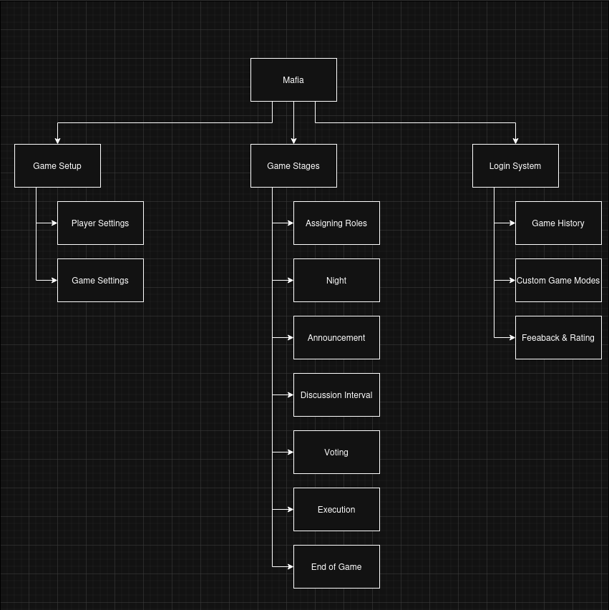

## Software Methodologies

| Methodology | Description | Benefits | Drawbacks |
| --- | --- | --- | --- |
| Waterfall | A linear methodology where each stage of development must be completed sequentially, with a focus on documenting each stage thoroughly for maintainability.. | +Detailed documentation allows the game to be more maintainable and built upon in the future | -The rigidness of the sequential stages means that if a mistake is made in earlier stages of development with will be difficult to go back  - Specific requirements of the game must be made clear from the start |
| Spiral | An iterative methodology that focuses solely on risk analysis and provides risk assessments for each spiral to avoid high risk projects failing. | +Risk analysis can help developers of the project know when to stop before going into a high risk phase | -Risk assessments can be expensive and time-consuming meaning there is less time to develop the game itself |
| Agile | An iterative methodology that focuses on producing prototypes for the clients to review during each stage and to continuously build upon them. | +Multiple prototypes mean the client can review each, giving feedback to improve the next one  +Higher flexibility for developing a game in the case of a mistake being made or unclear requirements | -A lower emphasis on documentation may lead limited future maintainability  -My clients must be in constant contact with the project manager (me) |
| Extreme Programming (XP) | An agile methodology that corely focuses on the quality of the code by utilising methods such as paired programming. | +Higher code quality can improve performance  +Higher code quality can also improve the maintainability of the code if there are new features proposed to be added to the game | -Too much emphasis on code may lead to a poorer user experience  -Constantly refining the code of the project may become time consuming overall |
| Rapid Application Development (RAD) | An agile methodology that corely focuses on producing the final product within a limited time frame by completing each stage through quick “sprints”. | +Less time is taken to produce the overall project | -The project may be poorly maintained if rushed |

Out of the methodologies listed above, the one best suited to the Mafia project would be the Agile methodology. This is because game projects must be consistently evolving to adapt to the needs of an active user base, meaning the methodology must be iterative to allow flexibility. Furthermore, Agile is the most balanced out of the iterative methodologies discussed above since it doesn’t involve involve trading off any major aspect of the project for another such as Spiral overanalysing the project is feasible at the cost of development time, or how RAD can reduce development time but at the cost of code quality and maintainability (the opposite if true for for XP).

## Research

There are many variants of this social dedication game (Mafia) which exist on the internet acting as alternatives to my proposed solution. In this Documentation I will be analysing the most popular solutions and weigh the benefits of and drawbacks of each, identifying gaps which my solution can potentially fix. The following mafia variant games I will be analysing are:

* Town of Salem
* Among Us
* Mafia Mobile Game

## Case 1: Town of Salem

Town of Salem is an online multiplayer mafia variant available on Android and iOS app stores. In this game the server/program itself manages the game roles, logic, etc. solving the “host” problem described above. However, this game requires an internet connection to play and an account must be made.

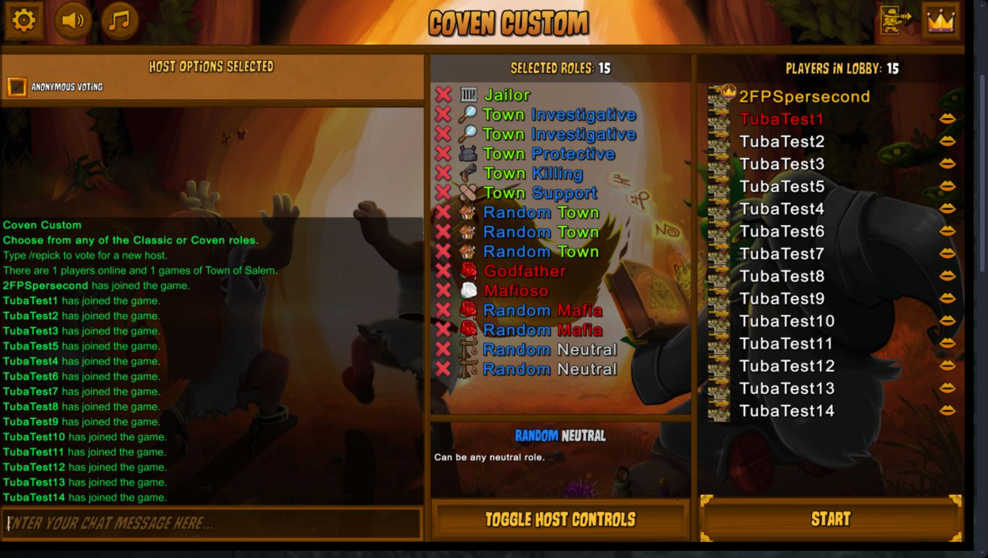

As you can see above, there is a plethora of of roles which can chosen allowing for a fresh experience each time the game is played.

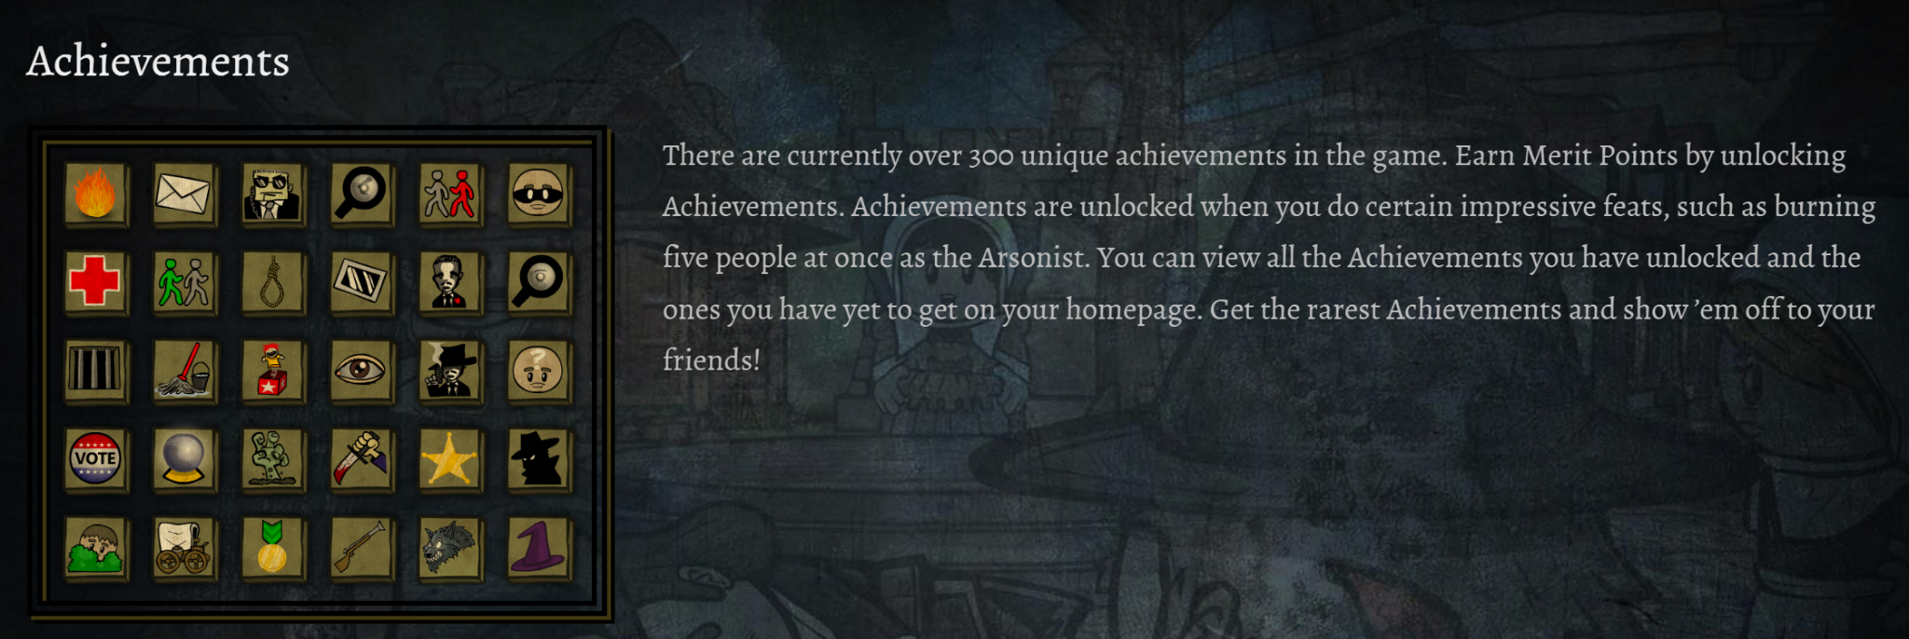

In addition to the many roles this game has to offer, there are a wide variety of achievements and awards the player can earn.

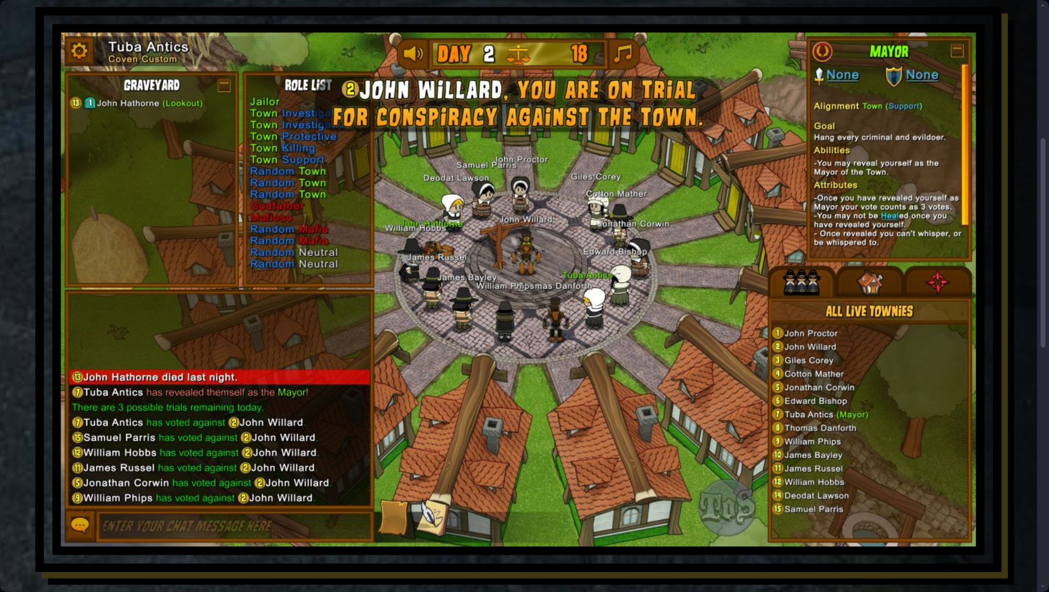

Interestingly, the whole game is digital with little to no physical interaction between the players allowing them to play from different parts of the world easily. The game represents each player as a small avatar which allows them to move around the map. They can also use the chat to communicate with other players. There is also a widget containing the information of their Roles, alignment and abilities, making it easier for new players to understand the game.

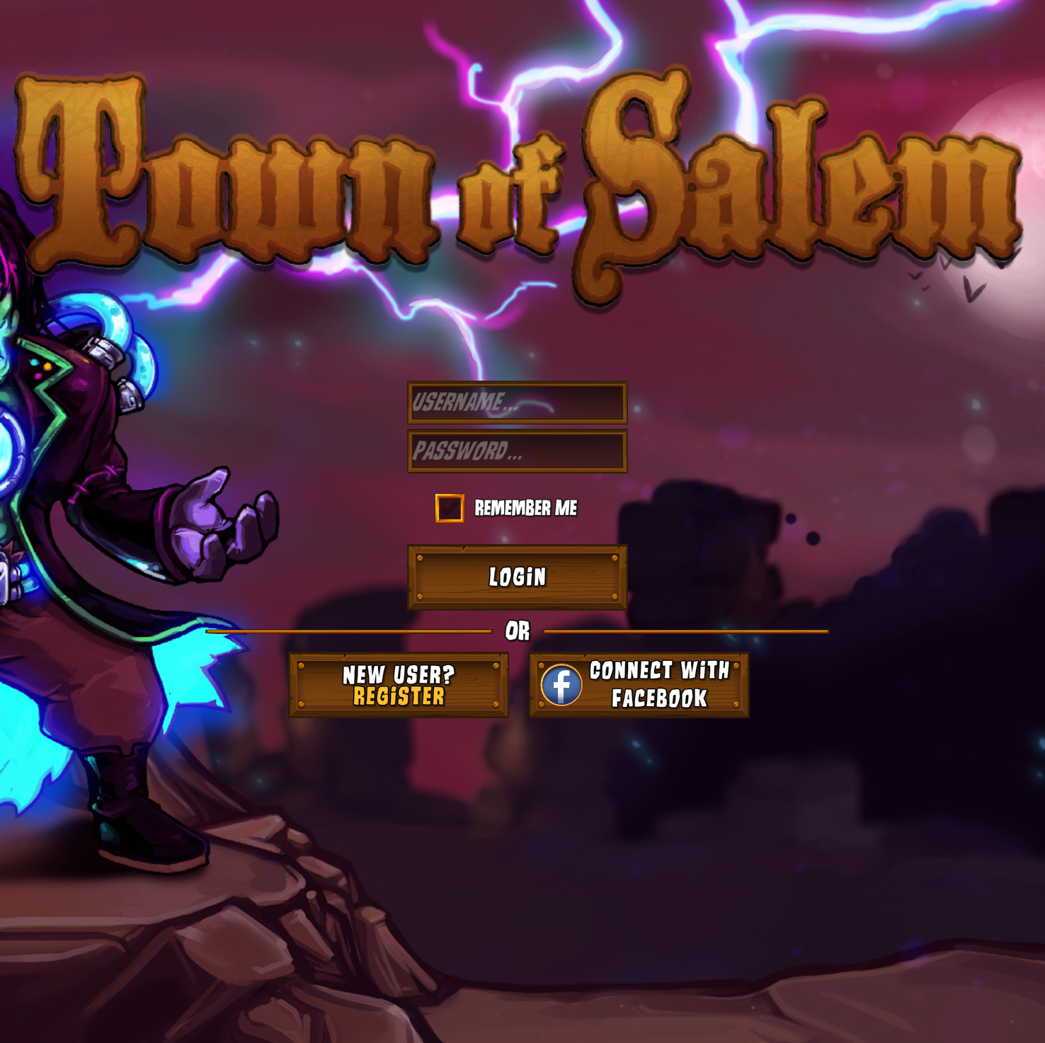

## Case 2: Among Us

Although not a traditional mafia game, Among Us still revolves around the same concept of an “Impostor” being among a group of players, with the addition of all tasks being completed by the “Crewmates” as an alternative way of winning the game.

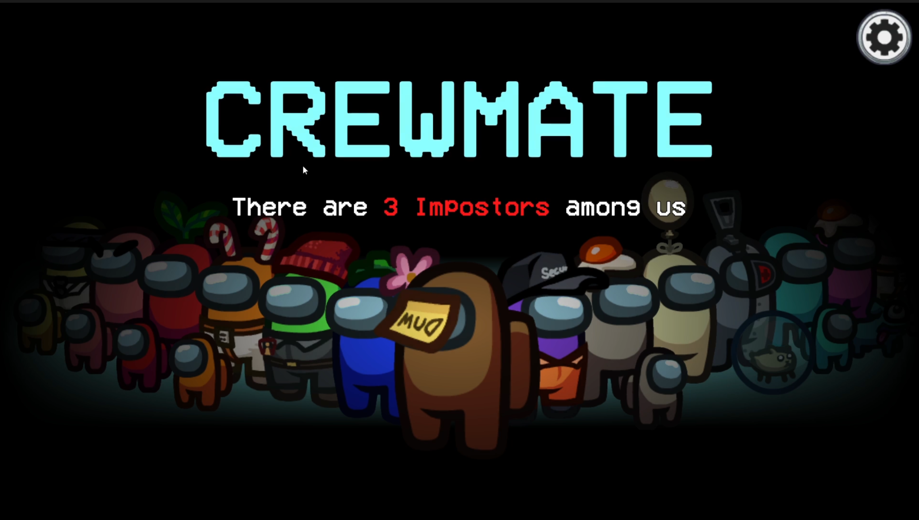

Similarly to Town of Salem, Among Us also lets players connect over the internet and play using accounts in the form of simple astronaut avatars.

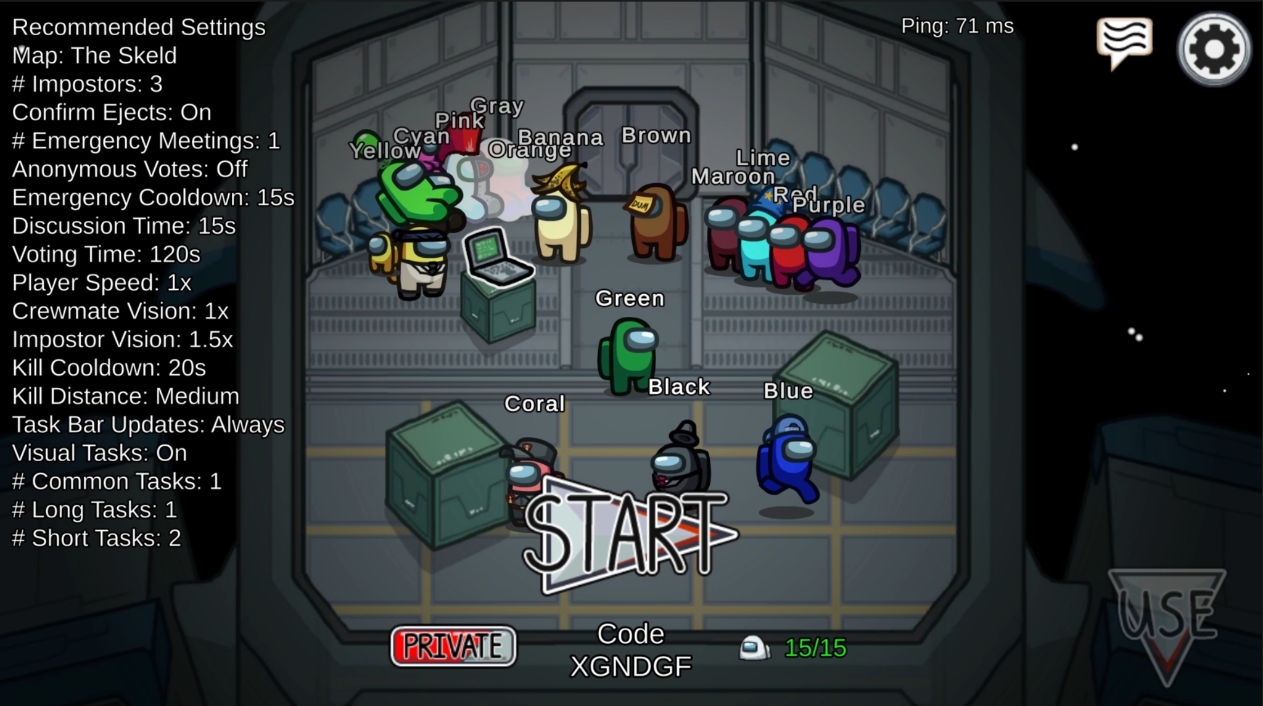

This game also allows players to customize the game settings, changing the mafia number, letting players run faster etc.

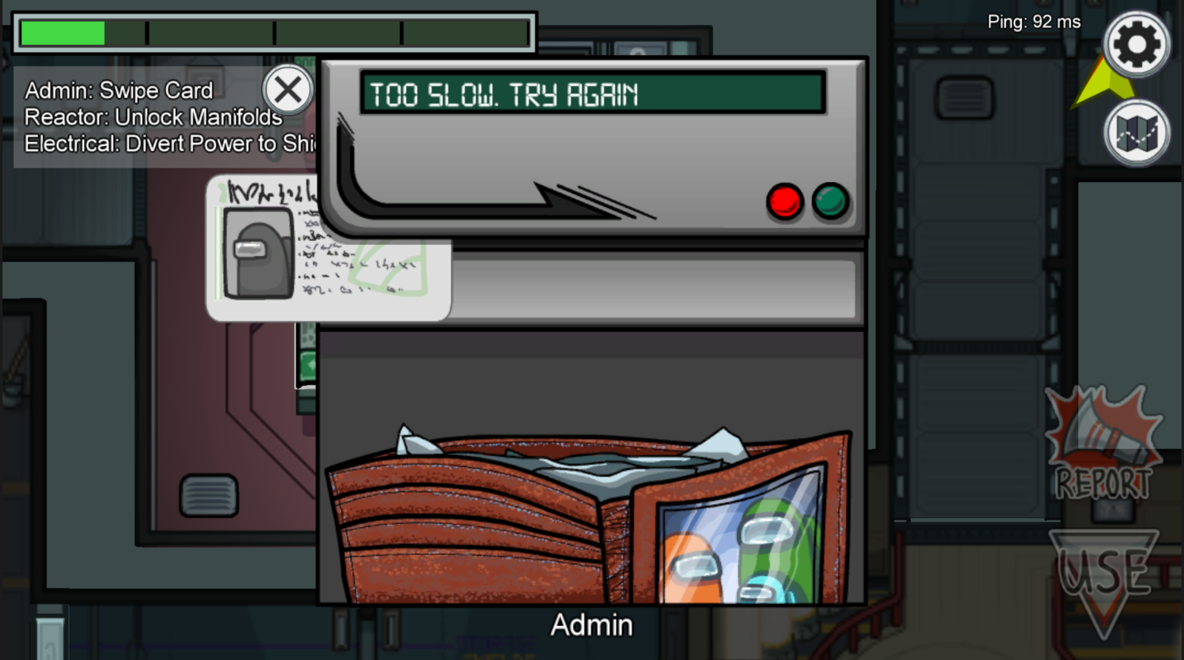

The tasks “Crewmates” must accomplish varies from sliding cars, to wiring circuits to uploading files, allowing the players to keep busy during the game.

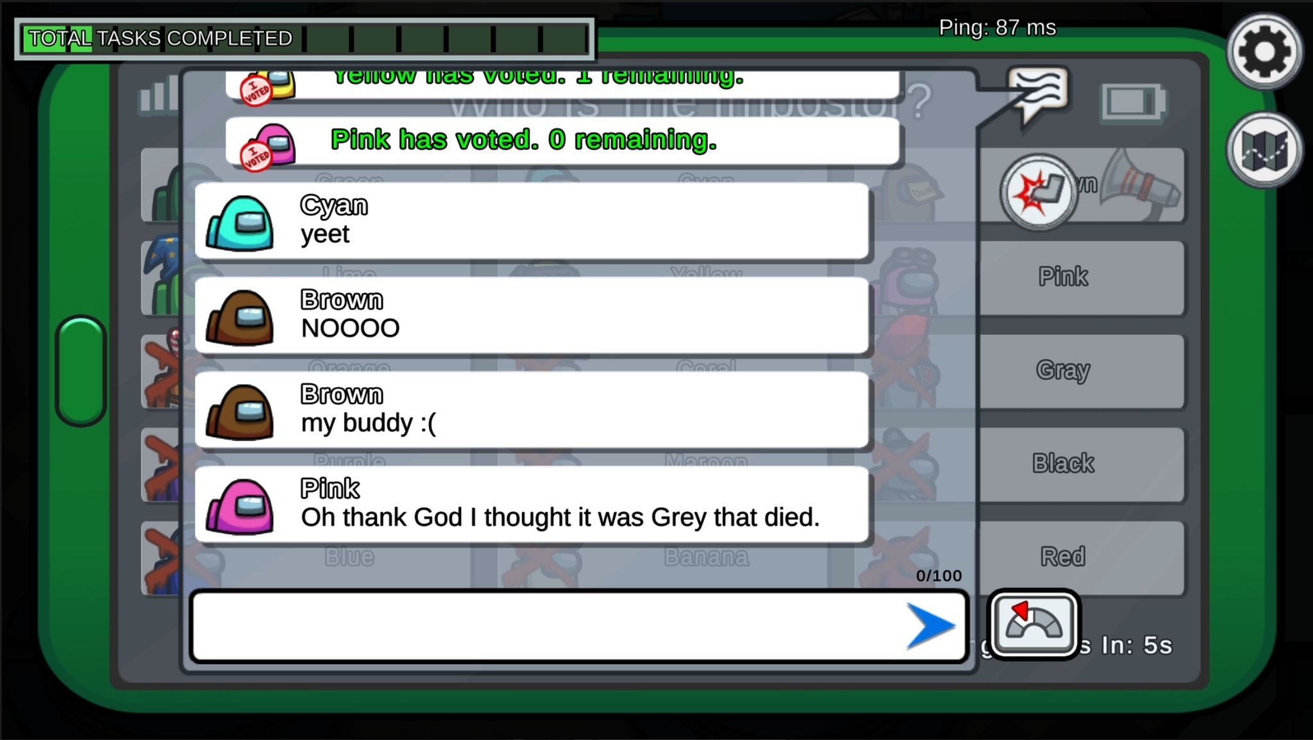

The players can also communicate with each other via a chat system, making the game accessible

